# Scott Galloway | .NET Developer | Remote

I'm a versatile and accomplished developer and lead with an over 25-year track record building teams and platforms, revitalizing startups and systems.

Proficient in C#, ASP.NET, and modern web frameworks, with extensive experience in cloud computing, DevOps, database management and search technologies. Proven track record of leading and managing successful development projects across diverse industries, from technology giants to innovative startups.

Email: scott.galloway@gmail.com

Phone: +44 7498 479 614

Consulting | Lead Developer / Architect / Managing Director | Remote 2

ZenChef Limited | Lead Contract Developer | Remote 2

Very Jane Ltd | Senior Contract Developer | Remote 3

Seamcor Ltd | Head of Engineering (Contract) | Remote 3

GBG Plc (Loqate) | Lead Engineer | Remote 3

WCOM AB | Lead Developer (Contract) | Remote 3

H3Space Ltd | Lead Engineer | Remote 3

Huozhi Limited | Technical Consultant / Dev Lead (Contract) | Remote 4

Interactive Reporting Limited | Lead Developer (Contract) | Remote 4

Dell | Development Lead | Glasgow, UK 4

Microsoft Corp. | Program Manager II | Redmond, WA, USA 4

Microsoft Ltd. | Application Developer Consultant II | Reading, UK 4

StormID | Lead Developer | Edinburgh, UK 4

## Skills

### Languages & Frameworks

Server Side: C# (25+ years), JavaScript (20+ years), ASP.NET to .NET 8 (25+ years). To a lesser extent: Python, Java, C++, PHP

Frontend: Vue.js, JQuery, HTMX, Alpine.js, React, Angular, Blazor (and many more)

CSS Frameworks: Tailwind CSS, Bootstrap, Manual

### Databases

SQL: SQL Server, PostgreSQL, MySQL, SQLite

NoSQL: MongoDB, RavenDB

### Cloud Computing & DevOps

Azure, Docker, Kubernetes

### Leadership & Software Development

Roles: Lead Developer, Senior .NET Developer, Development Lead, Head of Engineering, CTO

Methodologies: Agile, Scrum, Kanban

Tools: Jira, Trello, Azure DevOps, GitHub, GitLab

Managing: Both as a hands-on lead as well as agile engineering management developed teams and products.

Training: Developer training program with 90% employment success rate

Mentorship: Mentored junior developers and led geographically dispersed remote teams

## Professional Highlights

Proven Development Expertise: A 25+ year track record in driving full-stack software development, from hands-on coding to executive leadership roles.

Industry Impact: Made significant contributions to industry-leading organizations like Microsoft and Dell, as well as innovative startups across diverse sectors.

Remote Team Leadership: Spearheaded remote teams, fostering collaboration and innovation across global teams, while designing a developer training program with a 90% employment success rate.

Cutting-Edge Technological Focus: Continuously advancing expertise in modern development stacks, with a strong focus on remote and distributed work methodologies.

Strategic Product & Team Builder: Built and mentored high-performing development teams, leading them to deliver impactful products across industries, ensuring alignment with both business goals and user needs.

## Employment History

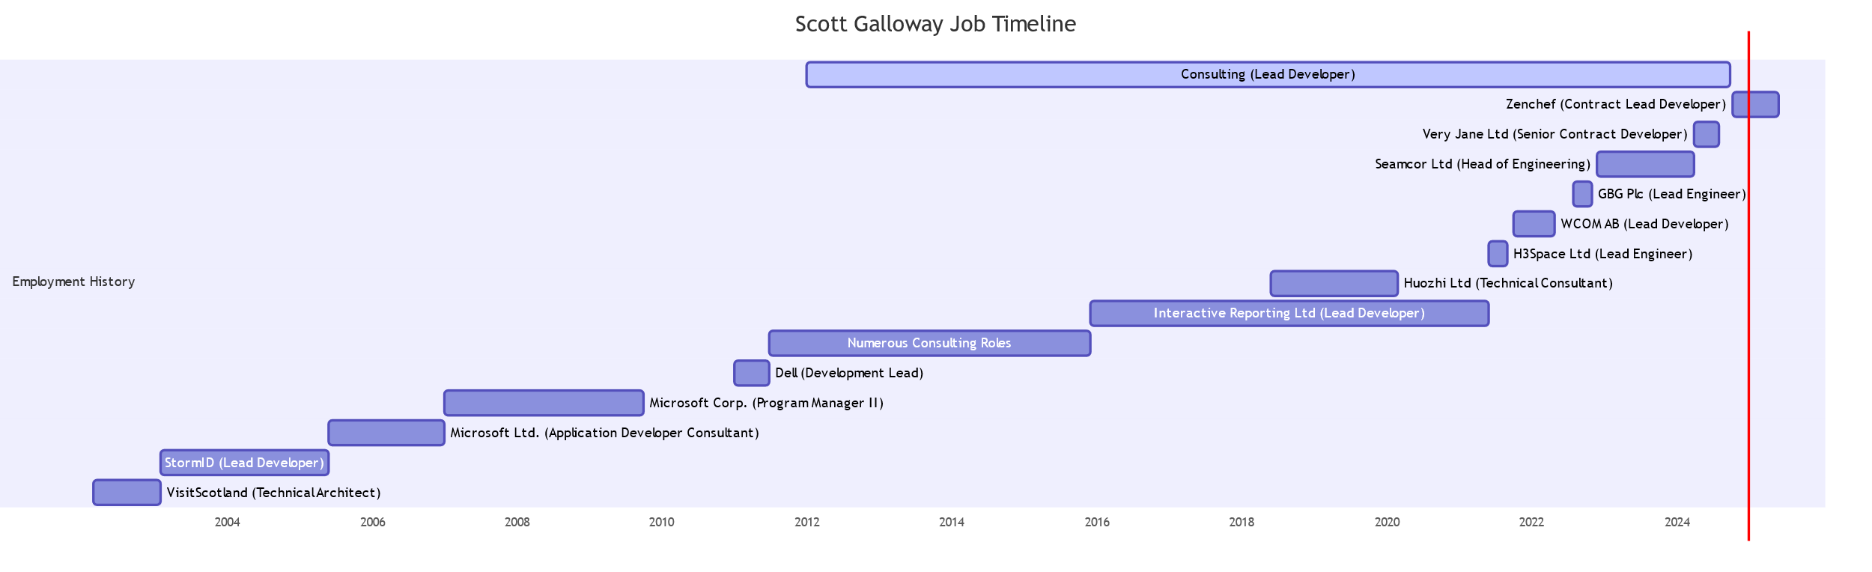

### Consulting | Lead Developer / Architect / Managing Director | Remote

Jan 2012 – Present

Directed multiple client projects as Lead Developer, Architect, and interim CTO, ensuring successful product launches and project completions.

Developed a comprehensive training program for over 200 novice developers, achieving a 90% employment success rate.

Modernized legacy systems, enhancing operational efficiency and user experience through advanced technological solutions.

Overhauled an e-commerce platform, improving performance, scalability, and maintainability.

### ZenChef Limited | Lead Contract Developer | Remote

Oct 2024 – Present

Brought in to manage the development of a very large legacy Azure based Distributed System. Rebuilt the system to use .NET 8 as well as improving scalability while substantially reducing hosting costs by reworking the application for improved efficiency and performance. Analyzed the performance and general approach to multiple areas of code using profiling and testing approaches.

### Very Jane Ltd | Senior Contract Developer | Remote

Apr 2024 – Aug 2024

Architected backend systems for a large e-commerce application, integrating payment systems like Stripe Connect and Hyperwallet.

Implemented ASP.NET 8 solutions to streamline product loading, payments, and promotions.

### Seamcor Ltd | Head of Engineering (Contract) | Remote

Dec 2022 – Apr 2024

Led a team of 6 developers in building and rearchitecting an ASP.NET Core system, integrating Docker Compose and OpenSearch for enhanced data access and reporting.

Ensured seamless transition and scalability of systems to meet evolving customer needs.

### GBG Plc (Loqate) | Lead Engineer | Remote

Aug 2022 – Nov 2022

Spearheaded the development of a global search product using .NET 6 microservices and Kubernetes, optimizing for high throughput and large data sets.

Set the technical direction for CI/CD, testing, and global-scale system operations.

### WCOM AB | Lead Developer (Contract) | Remote

Oct 2021 – May 2022

Executed various projects using Azure DevOps, Azure Functions, and Blazor Server for comprehensive reporting and microservices architecture.

Developed SignalR-based IPC and screen mirroring applications for enhanced user interaction.

### H3Space Ltd | Lead Engineer | Remote

Jun 2021 – Sep 2021

Built a development team and defined platform architecture for a scalable online community supporting a Unity 3D Desktop tool.

Delivered full-stack solutions using React JS, GraphQL, and Azure services.

### Huozhi Limited | Technical Consultant / Dev Lead (Contract) | Remote

Jun 2018 – Mar 2020

Provided technical leadership and team formation for a startup, returning to resolve development and release challenges.

### Interactive Reporting Limited | Lead Developer (Contract) | Remote

Dec 2015 – Jun 2021

Developed a web-based reporting platform using ASP.NET MVC, WPF, and WinForms, supporting multiple database backends.

### Dell | Development Lead | Glasgow, UK

Jan 2011 - July 2011

Led the development team building of a custom machine image deployment platform using ASP.NET MVC and SQL Server.

### Microsoft Corp. | Program Manager II | Redmond, WA, USA

Jan 2007 – Oct 2009

Drove the ASP.NET release lifecycle, managing bug triage and integration with the broader .NET community. Delivered core features and new security infrastructure for Project Server.

### Microsoft Ltd. | Application Developer Consultant II | Reading, UK

Jun 2005 – Jan 2007

Specialised in performance analysis and tuning for a wide variety of customers ranging from a large NHS project through smaller travel companies, software for the UK police etc. I led multiple performance labs in the Microsoft UK labs as well as in HPC applications in Stuttgart. Aided customers to deliver a very wide variety of systems whilst also liaising with numerous product teams at Microsoft corporate to assist customers in solving their development issues.

### StormID | Lead Developer | Edinburgh, UK

Feb 2003 - Jun 2005

Fast paced agency environment where I worked on many and varied projects from a massively scalable (.5 million+) mail merge system using ASP.NET, Windows Services etc through an Education Portal for Microsoft UK and multiple custom ecommerce systems which variously increased conversion rates by orders of magnitude.

## Education

University of Stirling | BSc (Hons) Psychology

Start Date: Sep 1992 - End Date: Jun 1996

Location: Stirling, Scotland, UK

## Links

LinkedIn: Scott Galloway

GitHub: <https://github.com/scottgal/mostlylucidweb> (my blog site / framework)